All questions are optional. Answer all or any, as you feel appropriate for you. For those printing this form, please continue on another sheet if you wish.
1. What do you like most about the Strettons?
2. What do you least like about the Strettons?
3. What are the special qualities of The Strettons as a place to live and work?
4. What issues do you think affect The Strettons (now or in the future?)
5. What positive change would you like to see and where?
6. What issues do you think that the neighbourhood plan* should cover and why?
*Neighbourhood plans are about guiding the future use and development of land in a way that meets the aspirations of the local community. For example they can identify sites or locations for development or redevelopment, type and tenure of new housing, protect the built heritage and natural environment (biodiversity and green spaces), set criteria for the design of new buildings, spaces, walking and cycling, sport, culture and well-being and set out what the area needs if it is to thrive. See www.csneighbourhoodplan.org and consultation leaflet.
Please help us to ensure we have reached a cross section of the community.
What is your postcode: |  | 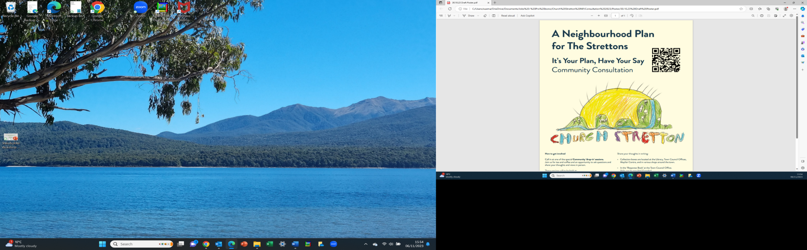  What is your gender?
Please circle/highlight your age group: |  | Please circle / highlight your employment status
Under 20  20 - 35  36 – 50  Prefer not to say | 51 – 65  66 – 80  Over 80 | Working full time  Working part time  Looking for opportunities | In education  Retired  Prefer not to say

